Daniel Levine

Dr. Dionisio

Interaction Design

Heuristic Evaluation

Usability is defined as the ease of use and learnability of a human-made object. Our group set out to see measure the usability of the web browsers Opera and Safari on a Mac OS using 5 different metrics as defined by the current consensus: 1.Time to learn (learnability),2. Speed of performance (efficiency), 3.Rate of errors by users (errors), 4. Retention over time (memorability),5. Subjective satisfaction (satisfaction). We determined 3 tasks to measure using 3 of the five metrics on each task to determine which of the browsers had superior usability. The tasks we decided upon were using each browser to print a page from the internet, set a homepage and zooming into the webpage. The three metrics we used to measure usability for each of the tasks were learnability,errors and satisfaction. We began the testing under the preconceived notion that Safari would be superior to Opera based on the knowledge that Safari is used more frequently than Opera and is widely considered to be a good browser. Through our testing we found that our hypothesis was correct, Safari fared much better in every task and gave nearly all users a higher level of satisfaction. Through my analysis I believe the higher level of satisfaction displayed in Safari over the level of satisfaction in Opera corresponds directly with the faster learnability in Safari and lower errors experienced when using Safari.

The creators of Opera consistently failed to relay their mental model to the users which led to multiple errors from our testers leading to far more complications(errors) than found in the Safari browser. The task that Opera consistently failed was the setting of a web page as the homepage, our group found that even if the user set a page as a homepage it would simply lead to the original start-up page this represents a huge miscommunication from the creators of Opera to its users. Opera in this task failed to follow some “golden rules” of interaction design because of its inability to cater to universal usability and prevent errors. Safari measure much higher in this task because they stayed consistent to what their users expect registering much higher levels of satisfaction because users were happy with the lack of errors.

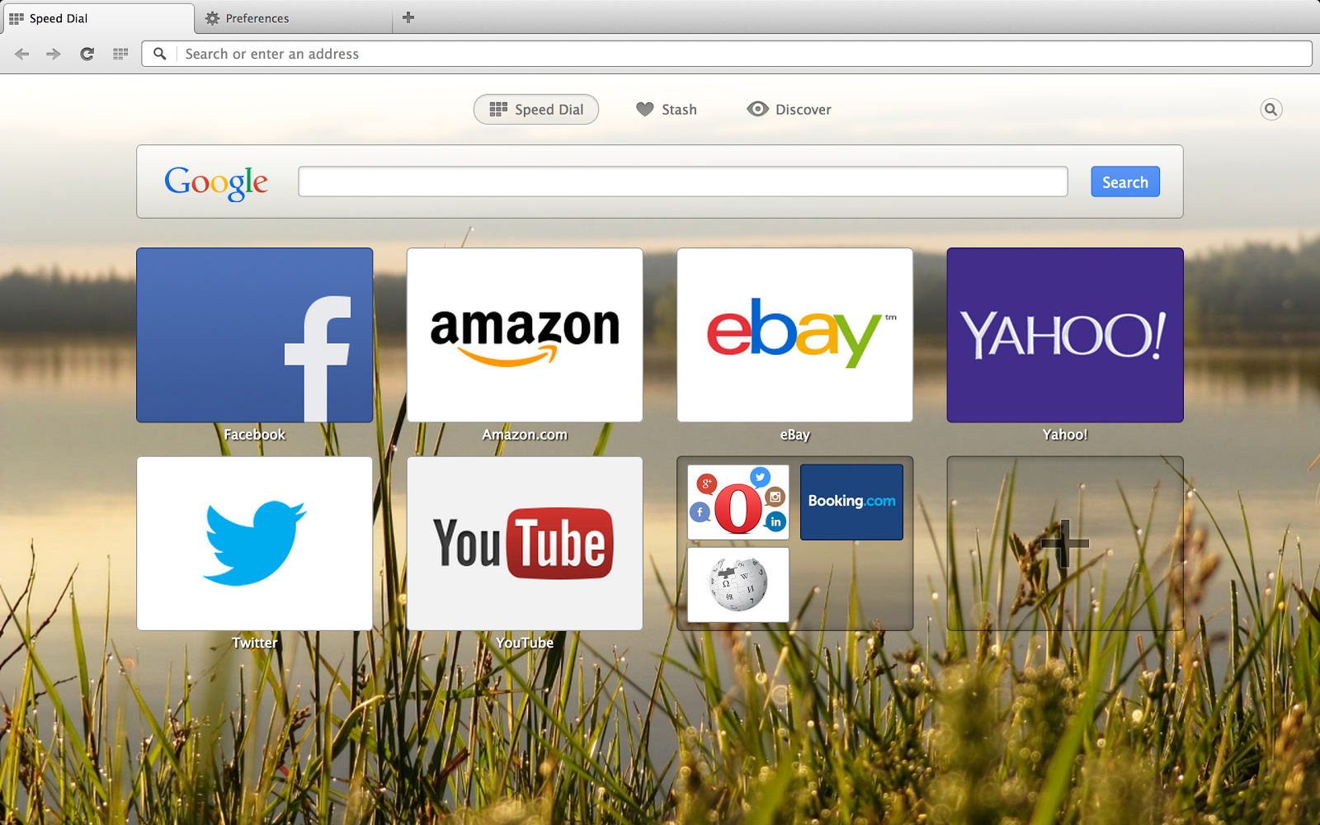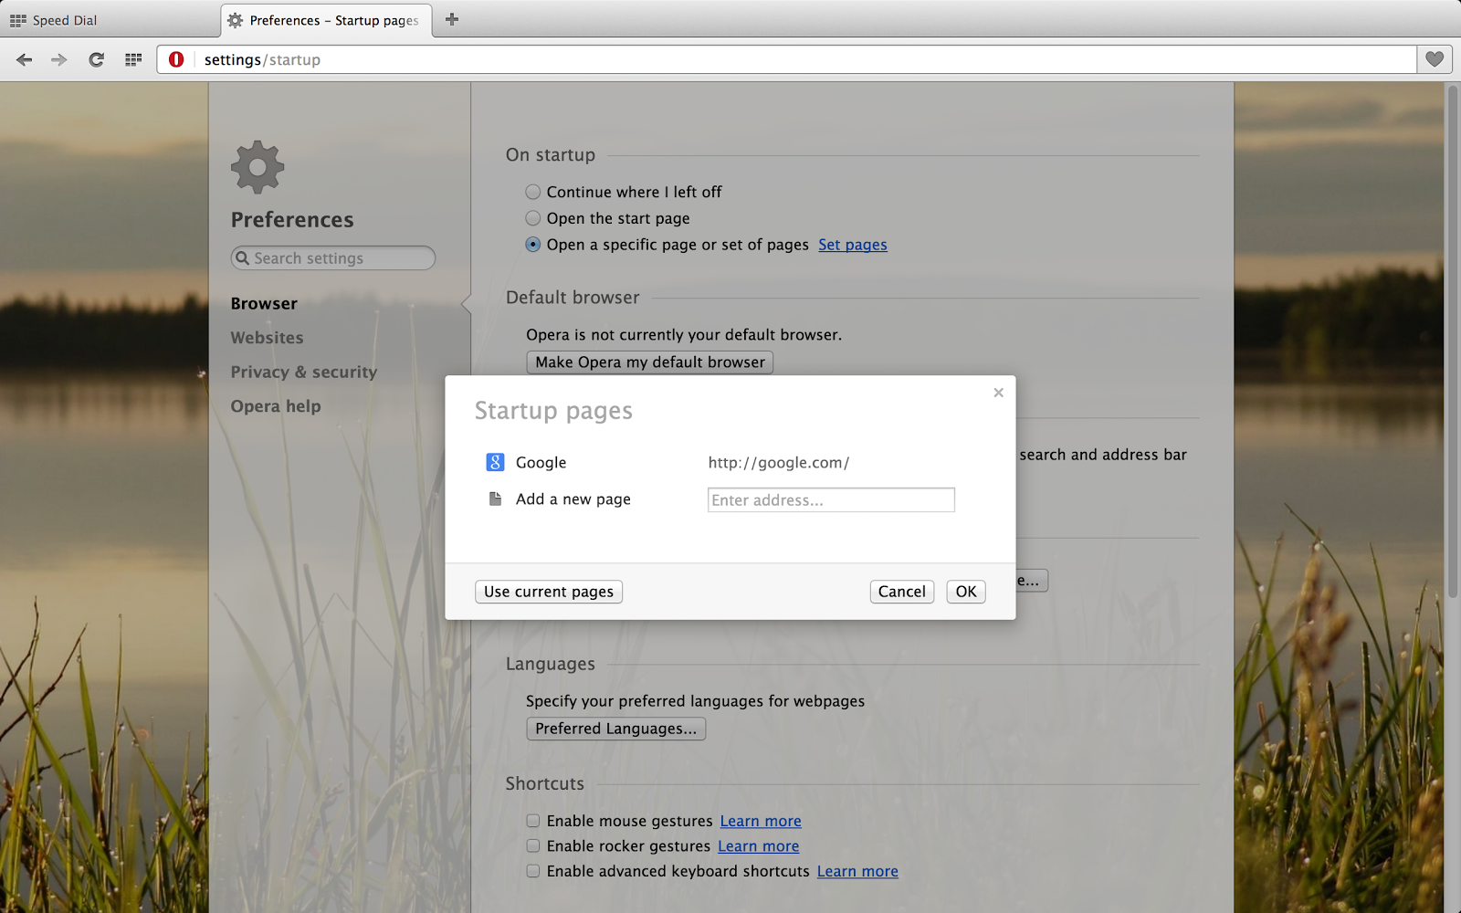

(*Figure 1*:Above on the left is the speed dial from Opera and on the right the new homepage is being set. After setting the new homepage user frustration skyrockets as the user realizes that the changes they made did nothing.)

The Safari browser performed better than anticipated during the usability testing in particular with the print a webpage task where testers were able to register fast times because the systems very high level of learnability. The same test on Opera registered a recurring error as the testers would try to print out the homepage to no avail as the browser could only print out a page that was not the homepage.

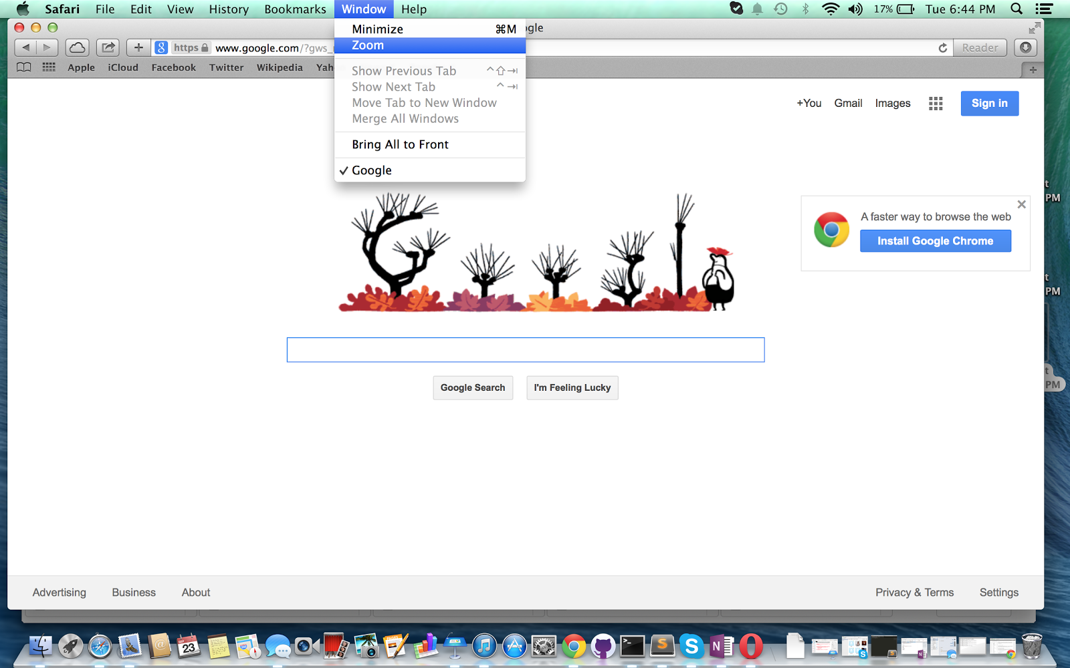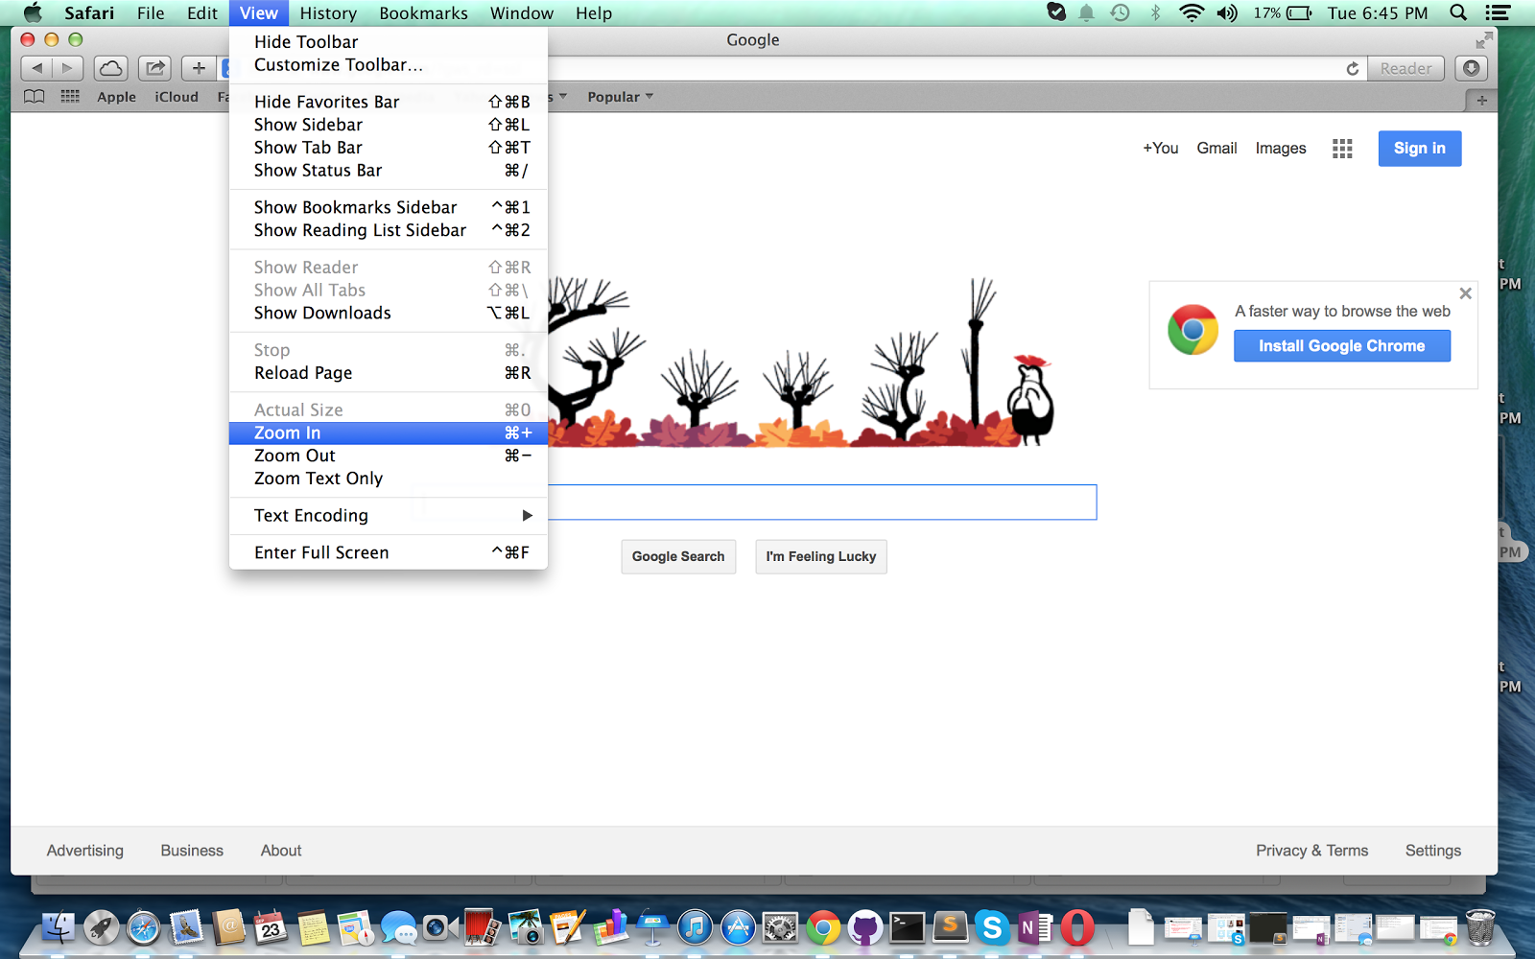 

(*Figure 2*: The screenshots above show the same problem in both of the browsers possibly because of a usability error in the Apple OS or the Apple guidelines.)

An error that plagued both of the browsers was found in the final task of zooming into a webpage. Each of the browsers have 2 different zoom functions on that increases the size of the window and one that enhances the browser, one is labeled zoom and the othered is labeled zoom(see Figure 2) in which caused confusion leading to errors in the usability of both browsers. Because both browsers came to the same error it leads me to believe that the guidelines for creating a browser in the Mac OS might be the problem and could possibly need in adjustment in this area to help with the usability of all browsers on a Mac system. In the screenshot above(figure 2) the usability issue is confirmed to be a product of apples guidelines.It was found the issue in usability stems from the name for the window enhancing button which is not intuitive enough, since the button to make the window smaller is the minimize button it would improve usability for apple to stay consistent and instead of calling the action/button zoom call it maximize.

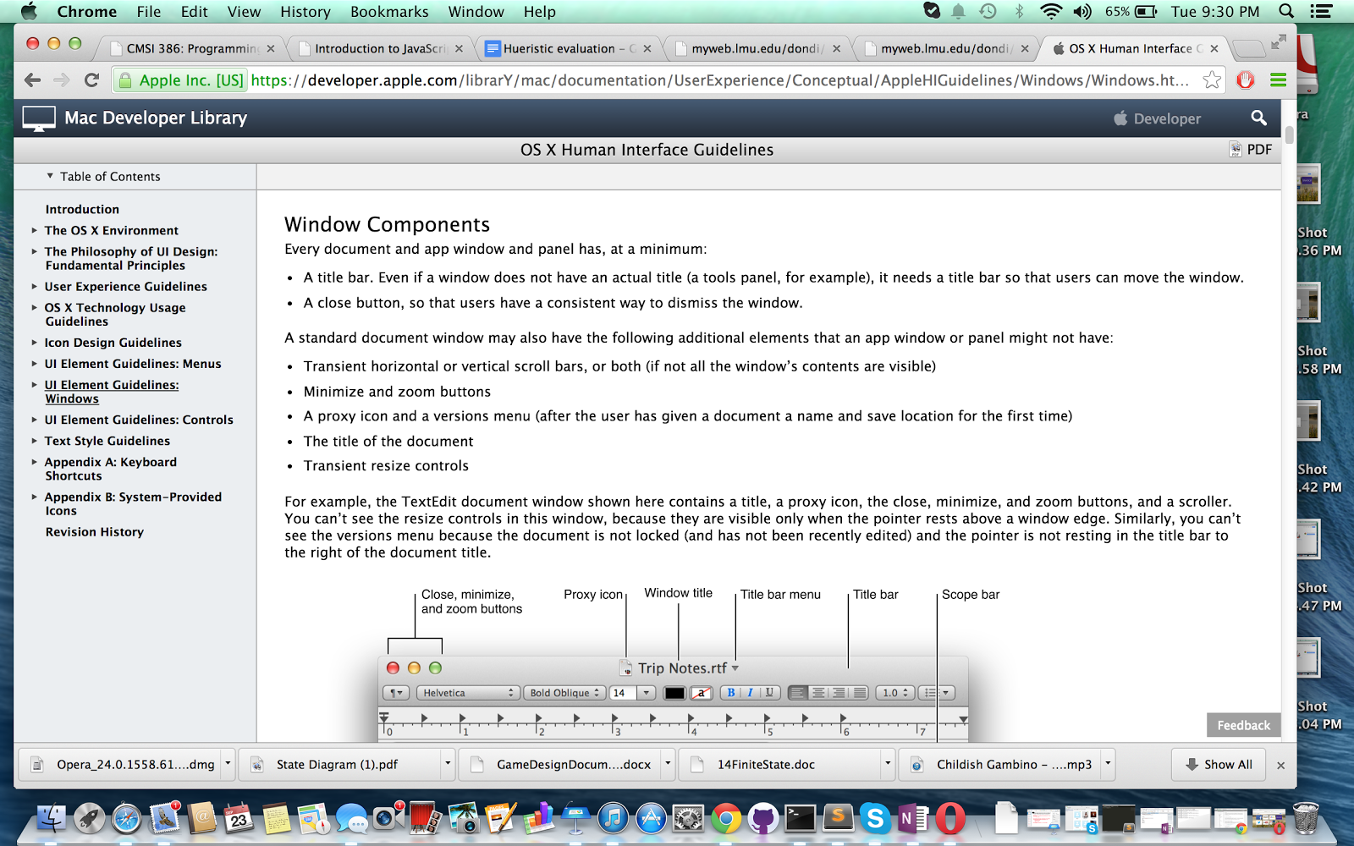

(*Figure 3*: The usability issue found in both of the browsers is a direct result of apples guidelines calling the maximize button the zoom button)

Even though Opera and Safari shared a similar error in the zooming task because of a faulty guideline in the Apple’s Human Interface Guidlines,Opera’s browser failed to measure up to the usability of Safari browser possibly due to a major disconnect between the developer’s mental model and the users mental model in the system image.